Exp No: 18
GENERATION OF PWM USING TIMER INTERRUPT
AIM:
To generate PWM using Timer interrupt.

OUTPUT:
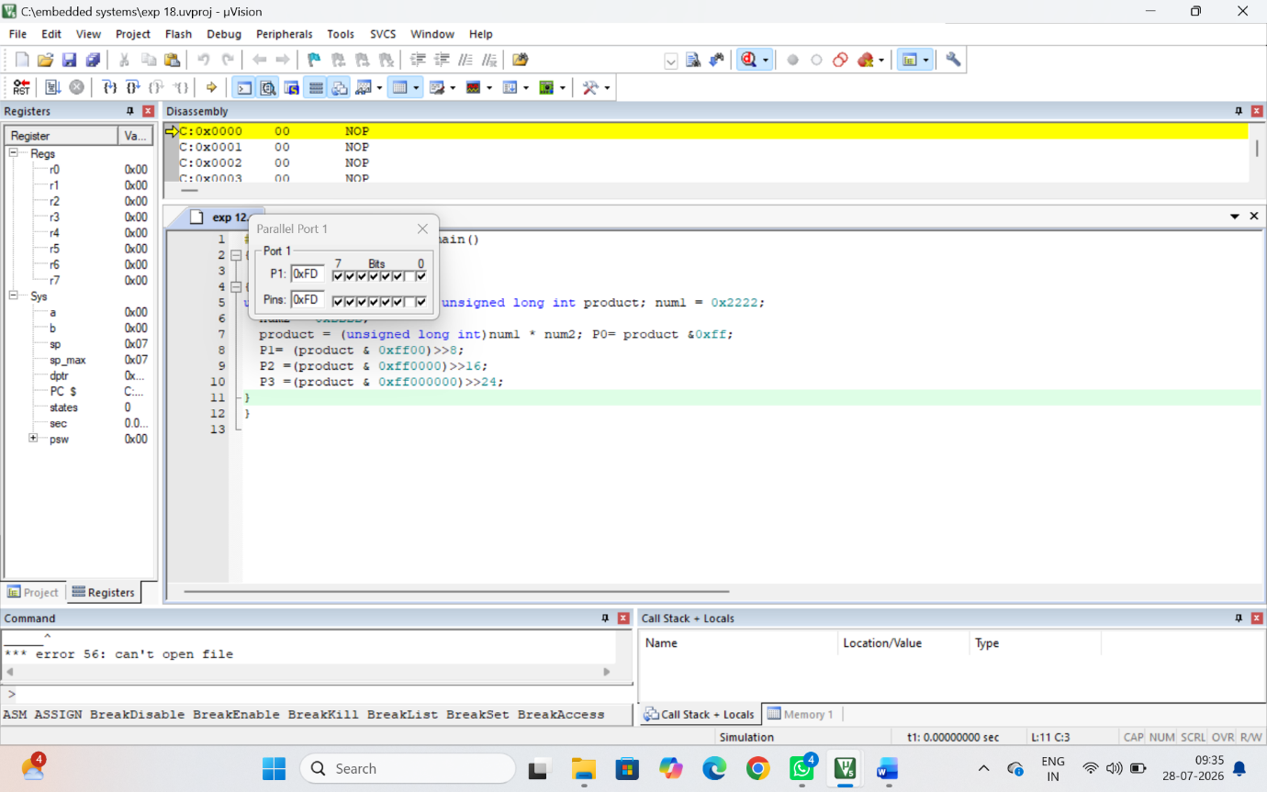

RESULT:

Thus the PWM was generated using Timer Interrupt for various duty cycle.

